**Assignment 2 Documentation**

**Name: Omar Amr**

**ID: K11776960**

**EX 5:**

**How to run?**

* This exercise is straight forward. It can be run through the terminal or through PyCharm.

**What works or does not work?**

* All the requirements of this exercise are fulfilled.

**EX 6:**

**How to run?**

* This exercise can be run through the terminal or through PyCharm.
* The turn of players is printed to the terminal as follows:
  + “Player's X turn” where X is either 1 or 2.
* The user enters a number between 1 and the width of the grid.
  + For example: If the grid width is 7, then the user enters a number between 1 and 7. Which means the numbering starts from 1 not 0.

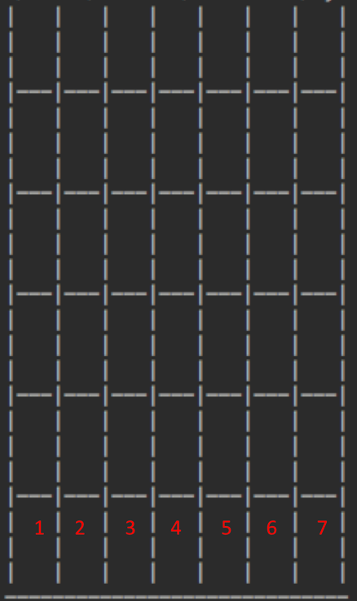

* The game ends when one of the players wins or the grid is totally full.

**What works or does not work?**

* All the requirements of this exercise are fulfilled.

**EX 7:**

**How to run?**

* This exercise can be run through the terminal or through PyCharm.
* Initially the user is asked to enter the number of rounds to be played.
* The turn of players is printed to the terminal as follows:
  + “Player's X turn” where X is either 1 or 2.
* The user enters a number between 1 and the width of the grid.
  + For example: If the grid width is 7, then the user enters a number between 1 and 7. Which means the numbering starts from 1 not 0 as shown in the figure above.
* The final score of the tournament is saved to a text file that shows the final status of all rounds and the winner of the tournament.

**What works or does not work?**

* All the requirements of this exercise are fulfilled.

**EX 8: (Pop Out is implemented as a bonus feature)**

**How to run?**

* This exercise can be run through the terminal or through PyCharm.
* Initially the user is asked to choose between normal mode or pop out mode.
  + 1 for “Normal” Mode or 2 for “Pop Out” Mode.
* Then the user is asked to enter the number of rounds to be played.
* The turn of players is printed to the terminal as follows:
  + “Player's X turn” where X is either 1 or 2.
* The user enters a number between 1 and the width of the grid followed by any number of white spaces then push or pull.
  + For example: If the grid width is 7, to push a tile in the 1st column the user should write ”1 push” without the quotations.
  + To pull a tile from the 2nd column, the user should type: “2 pull” without the quotations.
* The final score of the tournament is saved to a text file that shows the final status of all rounds and the winner of the tournament.

**What works or does not work?**

* All the requirements of this exercise are fulfilled.